GOLF CROQUET (GC)
- Winner of the coin toss goes first with blue OR second with red
- Blue starts followed by red, black, yellow, This order is continued throughout the game (or if playing secondary colours the order is: Green, Pink, Brown, White)
- The sides are: Blue&Black v Red&Yellow (or if playing secondary colours: Green&Brown v Pink&White).
- Balls all start within one yard from corner “IV” (START AREA)
- Once one ball is through hoop 1 (blue top) everyone moves on to hoop 2, followed by hoops 3-12. Winner is first side to score 7 hoops. If the score is 6 all, hoop 3 (GOLDEN HOOP) is replayed
- If 2 balls go through a hoop in the same turn, the one starting nearest the hoop claims the hoop
- OFFSIDE: If after a hoop is run, any ball is more than half way towards the next hoop, the opponents can direct the ball to one of the 2 penalty areas (EXCEPTION: If the ball became offside after contact with an opponent ball, this is not deemed to be offside) PENALTY AREAS are a one yard semi-circle (see diagram)
- Ball out of court: Replace ball just inside the line at the point where it left the court
- You can elect to miss a turn, DEEMING a ball as being played 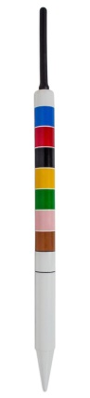
Centre Peg with order of play Primary & Secondary Colours

TWO STRIKE GOLF CROQUET (Bookham u3a)
Same as golf croquet except: after the 1st hoop has been run, if your ball hits another ball an extra strike is taken (2 strikes is the maximum strikes you can have in any one turn). Nb: If you hit into a touching ball you still earn an extra strike.
ASSOCIATION CROQUET (AC)
- The sides are: Blue&Black v Red&Yellow (or if playing secondary colours: Green&Brown v Pink&White). In your turn you can play either of your balls, and throughout your turn you continue playing with the selected ball. All 4 balls must be in play , before you can make your choice
- START: Place your ball 1 yard in from the South Boundary anywhere between “I” and halfway to “IV”. (or I yard in from the North Boundary between “III” and halfway to “II”)
- If you hit your ball through a hoop you get another turn
- If you hit your ball onto any other ball (Roquet), you pick up your ball and place it so that it is touching the ball that it hit. You then hit the two together so that both balls move (this shot is known as taking Croquet). You then hit your ball once more (Continuation)
- Each turn you can Roquet each of the other balls in this fashion only once. However if you go through a hoop in the course of your turn you can Roquet them all once again. This continues if you go through further hoops in your turn
- Croquet or Successful Hoop Run: If your ball finishes under a yard from the boundary it stays there
- Roquet and Continuation: If you hit a ball and it finishes off the court or under a yard from the boundary, replace it a yard in before continuing
- If you hit either ball off the court on a Croquet shot, your turn ends. If balls are hit off the court they are placed back on, 1 yard from the boundary
- After you have hit your ball through all the hoops (either 6 or 12), you hit it onto the peg (Peg-out). When a ball Is Pegged-out it is taken off the court. The first player to get both of their balls through all the hoops and Peg-out both of them is the winner
- If you are playing Handicap AC with Bisques, you can’t peg out your ball until its partner has run all its hoops (both Rover balls)
- ONE-BALL AC – Same rules as above, except each side plays with just one ball. BEWARE OF WIRING YOUR OPPONENT!
3 PLAYER NOMINATED 6 BALL AC (Bookham u3a)
- The sides are: Blue&Black V Red&Yellow V Pink&White
- Normal AC rules apply EXCEPT before you start your turn you nominate a pair of balls for Roquet purposes
- EXAMPLE: Blue can Roquet partner ball Black and in addition can nominate EITHER Red&Yellow OR Pink&White for roquet purposes
- There is no penalty or gain if you hit an un-nominated ball (scatterball)
- You must be Wired on all the other 5 balls to claim a Lift (Wiring Arises if an opponent leaves one of your balls in a situation where you cannot hit both sides of any other ball, or your swing is hampered by a hoop or the peg)

ADDITIONAL RULES FOR AC & GC
- GC Jump shots:(Mallet head <45 degrees) lawn must not be damaged
- Air shots count as a shot in AC but NOT in GC
- In AC, practice swings which hit any ball are not subject to penalty
- “In GC if you hit the wrong ball or go out of turn, simply replace the balls and continue with the right ball” (Bookham u3a)
- When balls are between 1/6th“ and 6” apart, ensure you do not “Double tap” or “Push” (ie hit your ball more than once)
- FIVE PLAYER GC: All 5 play as individuals (no sides)(Bookham u3a)

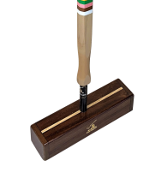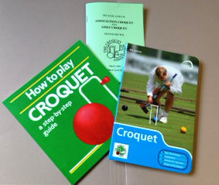
For books; mallets etc visit: www.croquetengland.org.uk
INTRODUCTION TO CROQUET
(Bookham u3a)
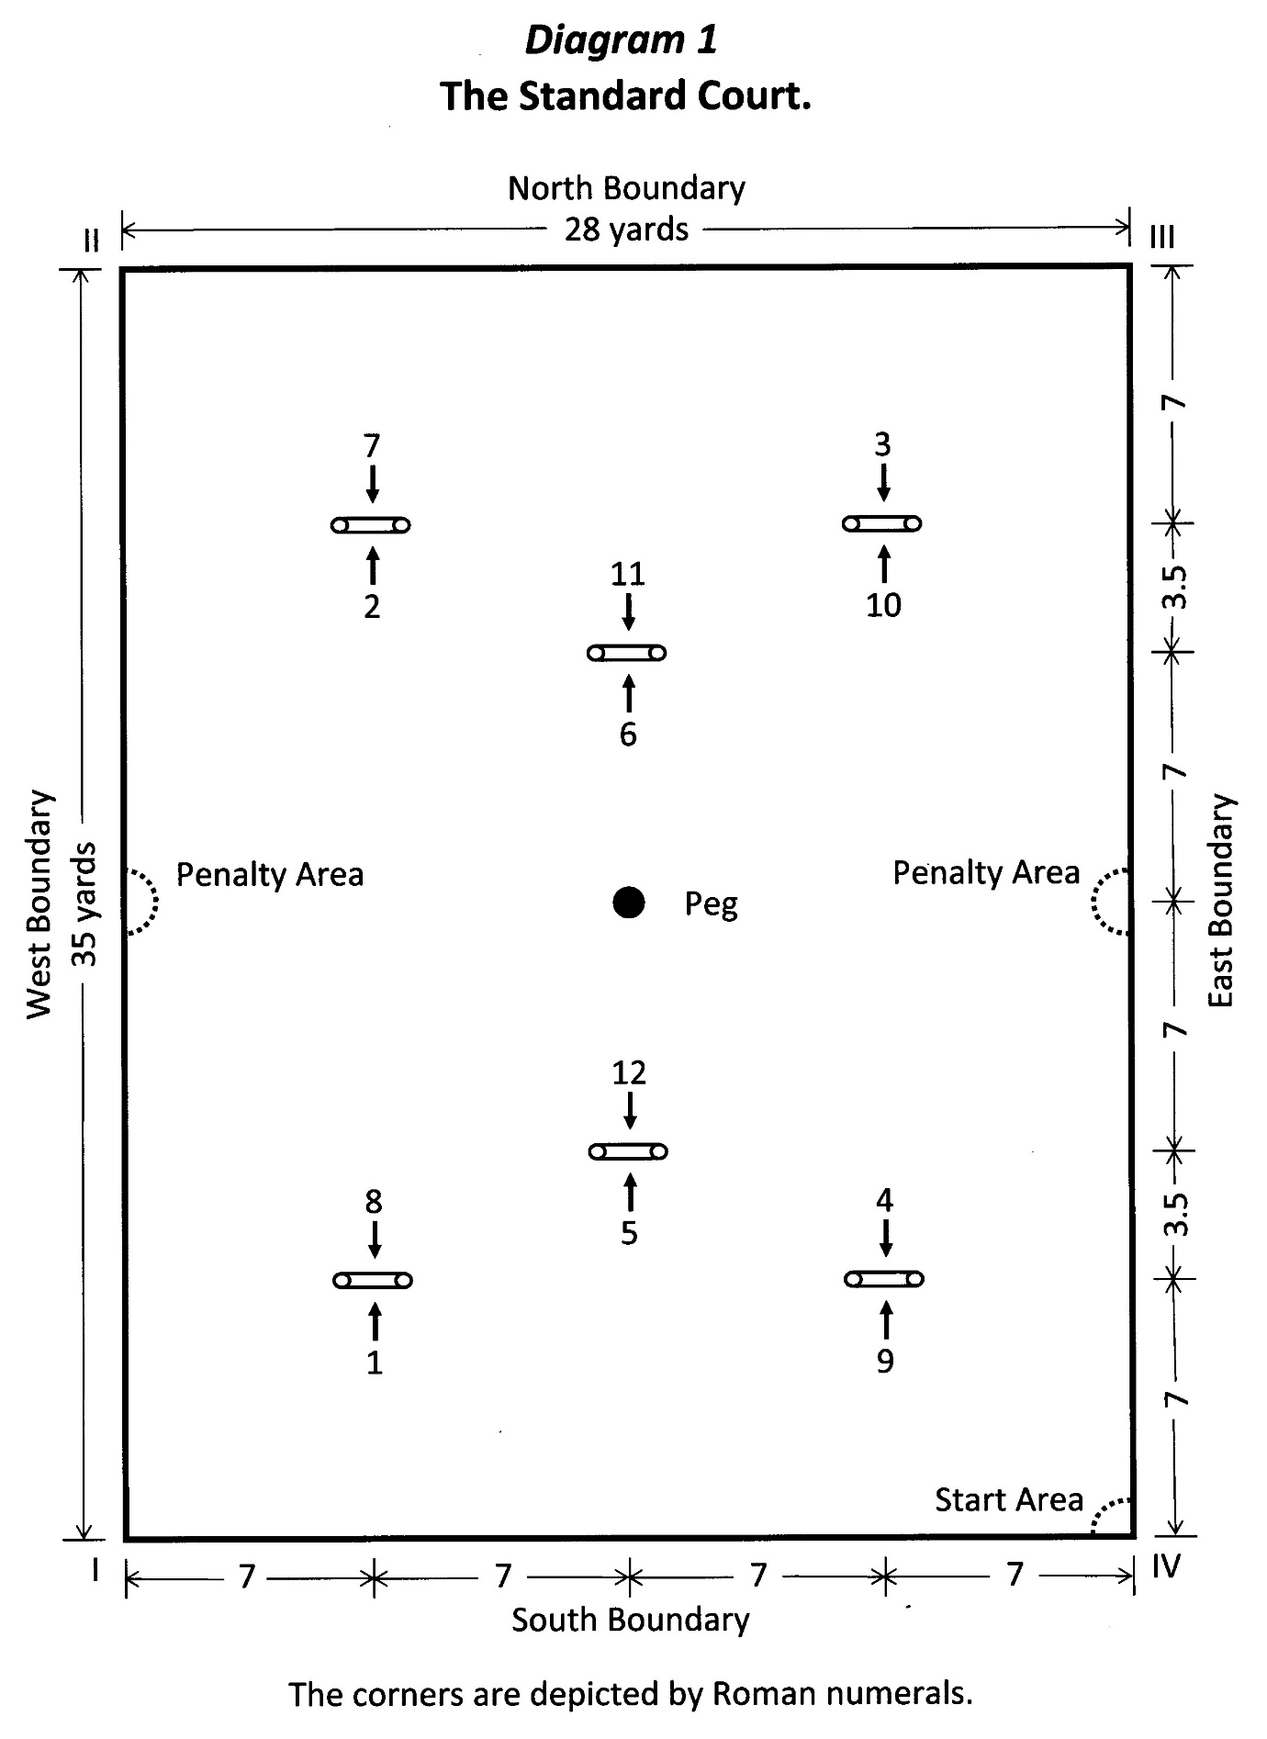
Start and Penalty Areas only apply to Golf Croquet

